ASSURE Lesson Plan
Author: | Mitchell LeStrange
Title of Lesson: | Google Earth Monument Tour
Content Area(s): | Geography/ Social Studies
Grade Level: | 9-12
Content Standard(s): | 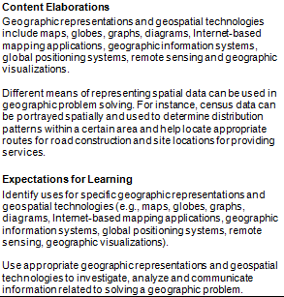
Technology Standard(s): | 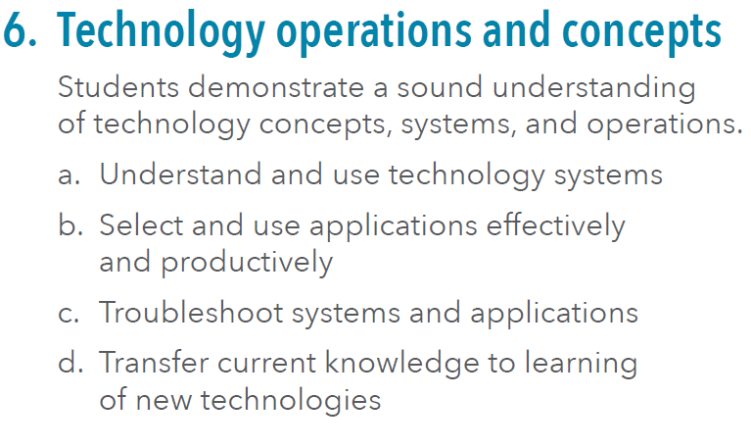
Time Required:
Analyze learners | Student breakdown according to ability
State objectives | Teach the students the important facts about the various important monuments in the world, and their historical significance.
Select methods, media, and materials | Methods  Teacher Demonstration (Google earth tour)  Students practice with teacher.  Students practice by filling out information about monuments  Individual assistance to every student.
Media & Materials
SMART Board
Google Earth software

Differentiation
Spend extra time with those students that my not learn or understand as well as other students, or students with learning disabilities.

Utilize media and materials (Procedures) | Teacher Preparation  Go through tour and see if it is working correctly
Lesson Procedures
Go through tour, stopping and talking about each monument
Require learner participation | Practice using SMART Board  Practice how to navigate online websites and videos  Practice how to play tour
Evaluate and revise | Students  - Special Education American Sign Language: Evaluate Google Earth presentation to learners who are deaf  - 21st century skills: Nonlinear thinking, communication through signs.  - Technology skills: Use Google Earth and Internet skills.
Instruction: Go through tour every night and review the monuments. Practice going through the tour and watch the videos.
Reflection/Revisions: Correct any possible mistakes in the project or tour.

